ECE 438 Lab, division 1
Lab 06 (week 07): Discrete Fourier Transform
and Fast Fourier Transform Algorithm (1)

Shijia Shu, [50%]_ _ _ _ _ _ _
Junyan Shi, [50%]_ _ _ _ _ _ _

March 3, 2016

Section 2

1.
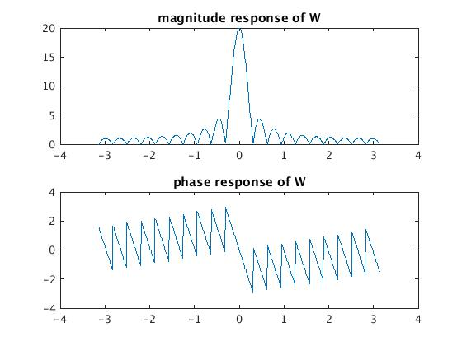
2. X(e^(jw)) = rep_2pi(pi*delta(w-pi/4)+pi*delta(w+pi/4)

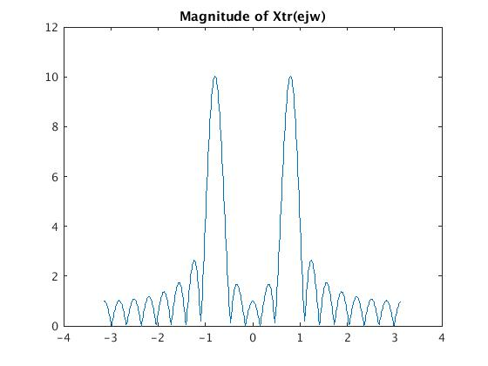
3.

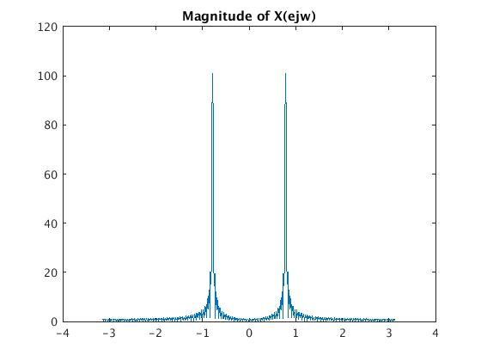
4. The difference between Xtr(ejw) and X(ejw) is that Xtr(ejw) seems to have some components of psinc function which is caused by the distortion of the truncation window.

5. My plot should be better using Hamming window, which has very small distortion to my signal.
It should just look like have two impulses.

Section 3

3.1

1.
function X = DFTsum(x)
%DFTSUM Summary of this function goes here
% Detailed explanation goes here
N = length(x);
X = zeros(1,N);
for k = 1:N
for n = 1:N
X(k) = X(k) + x(n) * exp(-i*2*pi*(k-1)*(n-1)/N);

end

end

end

2.
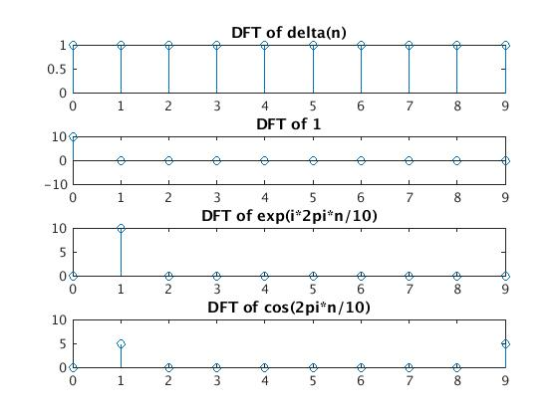
3. DFT(delta(n)) = 1,
DFT(1) = 10*delta(k),
DFT(exp(i*2pi*n/10)) = 10 * delta(k-1)
DFT(cos(2pi*n/10)) = 5 * (delta(k-1)+delta(k-9))
(for 0<=k<=9)

1.
function x = IDFTsum(X)
%IDFTSUM Summary of this function goes here
% Detailed explanation goes here
N = length(X);
x = zeros(1,N);
for k = 1:N
for n = 1:N
x(k) = x(k) + X(n) * exp(i*2*pi*(k-1)*(n-1)/N);

end

end
x = x / N;

end

2.
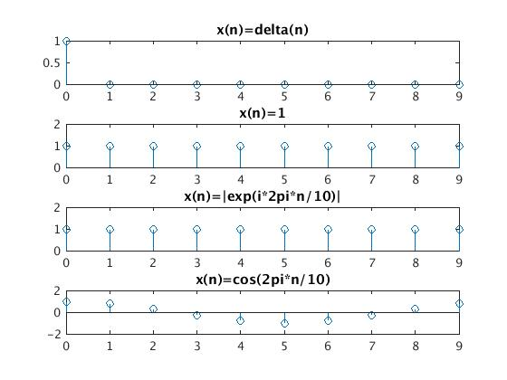

3.2

1.
A = DFTmatrix(5)
A =

1.0000 + 0.0000i 1.0000 + 0.0000i 1.0000 + 0.0000i 1.0000 + 0.0000i 1.0000 + 0.0000i
1.0000 + 0.0000i 0.3090 - 0.9511i -0.8090 - 0.5878i -0.8090 + 0.5878i 0.3090 + 0.9511i
1.0000 + 0.0000i -0.8090 - 0.5878i 0.3090 + 0.9511i 0.3090 - 0.9511i -0.8090 + 0.5878i
1.0000 + 0.0000i -0.8090 + 0.5878i 0.3090 - 0.9511i 0.3090 + 0.9511i -0.8090 - 0.5878i
1.0000 + 0.0000i 0.3090 + 0.9511i -0.8090 + 0.5878i -0.8090 - 0.5878i 0.3090 – 0.9511i

2.
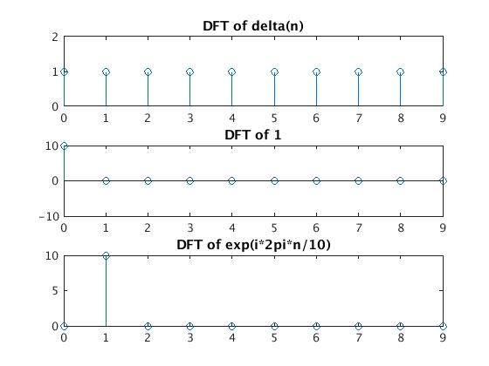
3. N^2 multiplies for each entry;
N multiplies for each vectors;

1. B(k,n) = exp(i*2*pi*(k-1)*(n-1)/N)/N

2. B = IDFTmatrix(5)
B =

0.2000 + 0.0000i 0.2000 + 0.0000i 0.2000 + 0.0000i 0.2000 + 0.0000i 0.2000 + 0.0000i
0.2000 + 0.0000i 0.0618 + 0.1902i -0.1618 + 0.1176i -0.1618 - 0.1176i 0.0618 - 0.1902i
0.2000 + 0.0000i -0.1618 + 0.1176i 0.0618 - 0.1902i 0.0618 + 0.1902i -0.1618 - 0.1176i
0.2000 + 0.0000i -0.1618 - 0.1176i 0.0618 + 0.1902i 0.0618 - 0.1902i -0.1618 + 0.1176i
0.2000 + 0.0000i 0.0618 - 0.1902i -0.1618 - 0.1176i -0.1618 + 0.1176i 0.0618 + 0.1902i

3. C = B*A

C =

1.0000 + 0.0000i -0.0000 + 0.0000i -0.0000 - 0.0000i 0.0000 - 0.0000i 0.0000 - 0.0000i
-0.0000 + 0.0000i 1.0000 - 0.0000i 0.0000 - 0.0000i 0.0000 - 0.0000i 0.0000 - 0.0000i
0.0000 + 0.0000i -0.0000 + 0.0000i 1.0000 - 0.0000i 0.0000 - 0.0000i -0.0000 - 0.0000i
0.0000 + 0.0000i 0.0000 - 0.0000i 0.0000 + 0.0000i 1.0000 + 0.0000i -0.0000 - 0.0000i
0.0000 + 0.0000i 0.0000 + 0.0000i -0.0000 + 0.0000i -0.0000 + 0.0000i 1.0000 – 0.0000i

C should be the 5*5 Identity matrix, because A is DFT matrix B is iDFT matrix, so A = B^(-1), this is why A*B = I

3.3
using DFTsum:
ans =

0.0600

using DFTmatrix
ans =

0.0100

Computing by DFTmatrix is faster. But DFTsum requires less storage.

